Berry Landcare

Foxground Sub-tropical Rainforest:
There are many incredible natural features in the Berry surrounds. One not often encountered is the Subtropical Rainforest Remnants that are easily seen from Berry - the upper escarpment. The Illawarra Subtropical Rainforest (an Endangered Ecological Community) represents the Southern extremity of this subgroup of rainforests on the Eastern seaboard of Australia. The Subtropical Rainforest is a dense community of moisture loving trees, mainly evergreen, broad leaved species, usually arranged in several layers, and containing vines, flowering trees, buttressed trunks and many other life forms. Berry Landcare together with Illawarra Landcare is gathering seeds from many plant communities around Berry for the creation of a seed bank. Recently a group of Landcarers visited the property “Bolwarra” in Foxground to collect seeds. This property through weed eradication has become one of the finest examples of ISR in the area. The name “Bolwarra” is taken from the native plant known also as Native Guava. The major part of the forest is on a steep rock strewn scree slope. The range of trees represented is typical and included Coachwood, Illawarra Socketwood (a threatened species), Myrtle Ebony, Sassafras, Koda, Pigeonberry Ash, Yellow Ash, Small Leaf Fig, Red Cedar, Birdlime Tree, Buff Hazelwood and Crab Apple. There were many plants including vines, ferns and flaxes totalling 232 native plant species. One Kangaroo Vine was as thick as a cyclist’s thigh. Seeds found on the ground included Yellow Ash and Crab Apple. The forest has the feel of the interior of a French Cathedral. This experience is one of the exciting results of being involved in Landcare.

Weed and Native of Month:
An erect shrub has recently grown on the side of the road adjacent to the turn off into Tindalls Lane from the highway. In spring its long, flexible needle like bright green leaves were covered in sprays of yellow flowers. Initially it was thought to be Spanish Broom, (Spartium junceum)” and it would have to go. On closer examination however it was obvious it was a native. “Native Trees and Shrubs of South East Australia” revealed it was Golden Spray (Viminaria juncea) often referred to as Native Broom. You will notice the similarity in the nomenclature (juneceum – juncea). The Latin junceum means "rush-like", referring to the shoots, which resemblance to those of the rush genus Juncus.
This beautiful plant is not common to the Berry area and has probable come from passing traffic. Spanish Broom however has taken hold in many places with a Mediterranean climate and is regarded as a noxious invasive species in south eastern Australia.

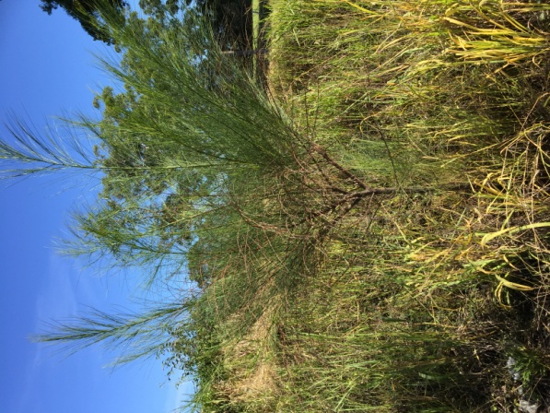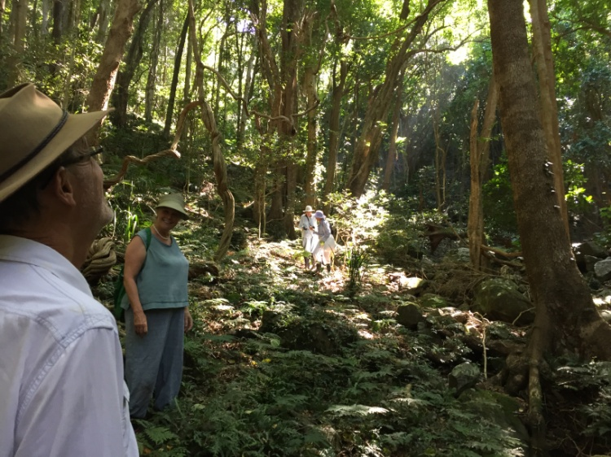
Golden Spray Bolwarra

Working Bees for May 2016:
Alexandra Street Parkcare: 9-11 am Friday 20th May: Gail Paton 44487915.
Broughton Vale: 2-4 pm Sunday 1st May: Barry Virtue 44641389.
Bong Bong Road: 9-11am Sunday 8th May: Julia Woinarski 4464 2084.
Bundewallah Bushcare: 2-4pm Sunday 29th May: John Clark 44643911.
Camp Quality: 9-11am Sunday 15th May: Jeanne Highland 4464 1271.
David Berry Hospital: 2-4pm Saturday 20th May: Leslie Pigott 44643241.
Mount Coolangatta: 1-3 pm Saturday 20th May at end of Roxbrough Rd, Far Meadow.
Be on time to get a lift to site: Myke Cunningham 0418 297 435 or mcunningham@pci.cx.
Mark Radium Park: 9-10am Friday 27th May: Rodney Cole 4464 1475.
Tindalls Lane: 2-4pm Sunday 8th May: Harvey Blue 4464 1880 or Jim Jefferis 4464 2988.
Information can also be found at Berry Landcare on Facebook.
Plant identification service: Please contact Harvey Blue 4464 1880 or Ian Parker, 4448 6359.
Visit our pages at: http://www.landcare.nsw.gov.au/groups/berry-landcare for more on Berry Landcare and late changes to working bee details. Information can also be found on Facebook.

